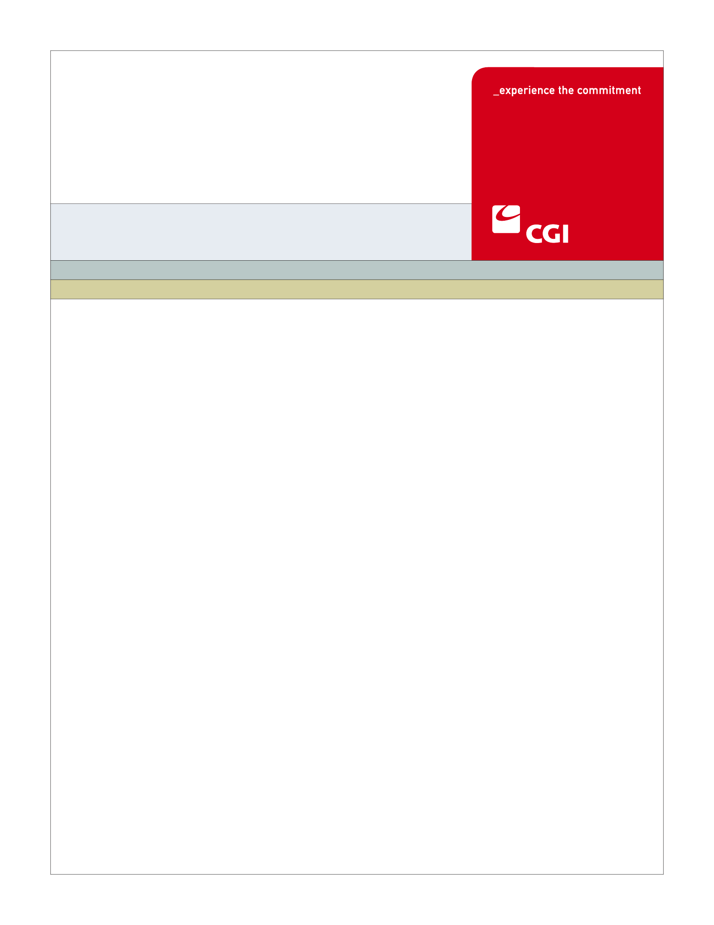

USE
Colorado Health Benefit Exchange (COHBE)
Version 1.1
October 30, 2012
BN-001B
Third Party Certification
(Navigator’s)
Use Case
REVISION HISTORY
Version | Date | Modified By | Description
0.1 | 2012-08-23 | Derek Sullivan | Initial Draft
0.2 | 2012-10-01 | Derek Sullivan | Discovery session updates
0.3 | 2012-10-08 | Derek Sullivan | Elaboration session updates
1.0 | 2012-10-16 | John Williams | Verification session updates
1.1 | 2012-10-30 | Derek Sullivan | COHBE Updates

TABLE OF CONTENTS
1 Use Case: Navigator Certification 5
1.1 Goal 5
1.2 Brief Description 5
1.3 Requirements Traceability 5
1.4 Primary Actor(s) 5
1.4.1 Back Office 5
1.5 Secondary Actor(s) 5
1.5.1 Navigator 5
1.5.2 Navigator Entity 5
1.5.3 Learning Management System 6
1.5.4 Exchange 6
1.6 Pre-Conditions 6
1.7 Post-Conditions 6
1.8 Triggers 6
1.9 Assumptions 6
2 Flow of Events 7
2.1 Basic (Main) Flow – Navigator Certification 8
2.1.1 Checks LMS Third Party Training Completion 8
2.1.2 Has Navigator Completed COHBE Navigator Training? 8
2.1.3 Updates Navigator Account to Certified 8
2.1.4 Sends Navigator Account Certification Notification 9
2.1.5 Receives Certified Navigator Account Notification 9
2.1.6 Receives Account Notification Allowing Navigator to do Business on the Exchange 9
2.1.7 Provides Third Party Training Completion List 9
2.1.8 Next Steps 9
3 Alternate Flows 9
3.1 COHBE Navigator Training Completion 9
3.1.1 Does Navigator Want to Participate in COHBE Navigator Training? 9
3.1.2 Resolve COHBE Navigator Training Discrepancy 9
4 Exception Flows 9
5 Specifications 10
5.1 Business Rules 10
5.1.1 LMS Third Party Training Verification 10
5.2 Process Rules 10
5.2.1 Has Navigator Completed COHBE Navigator Training? 10
5.3 Workflow 10
5.3.1 Worklist Definition 10
5.4 UI Screen Details 11
5.5 Communications 11
5.5.1 Imaging Requirements 11
5.5.2 Form Requirements 11
5.5.3 Notices Requirements 11
5.5.4 Other Communication Requirements 11
5.6 Interfaces 11
5.7 Reporting 12
5.7.1 Navigator Training List 12
5.7.2 User Experience 12
5.7.3 Business Activity 12
5.7.4 Workflow 12
5.7.5 Community and Public Health 12
5.8 User Security 12
5.8.1 Actor Status Changes 12
5.8.2 Sensitive Data Used 13
5.9 Activity Log and Audit Trail 13
6 Future Release Notes 13
7 Appendix A - Glossary 13

Use Case: Navigator Certification

Goal
The goal of this Use Case is to certify a Navigator to use the Exchange.
This Use Case completes succesfully when the Navigator is certified by the Exchange and their account is updated indicating they may provide asisstance on the Exchange.

Brief Description
Before this Use Case begins, the Create Navigator Account Use Case must be completed in order for the Back Office to initiate the certification process from the Exchange. Once a Navigator is provided with an account on the Exchange, the Back Office will begin its certification process.
This process will ensure that the Navigator has completed the COHBE specific Navigator training through the Learning Management System (LMS). Once certified, the Navigator’s account will be modified by the Back Office to indicate that the Navigator is now allowed to provide assisstance on the Exchange.

Requirements Traceability
The following requirement is covered within this Use Case:
- SH124: The Exchange shall only allow brokers and navigators who have completed training on the Learning Management System (LMS) to be certified.

Primary Actor(s)

Back Office
The Back Office will conduct the manual certification process and update the Navigators account reflecting the certification process.

Secondary Actor(s)

Navigator
If required, the Navigator will provide additional supporting materials.

Navigator Entity
The Navigator Entity receives notifications of certified Navigators.

Learning Management System
The Learning Management System will provide the Back Office with a daily list of Navigators that have participated in COHBE Navigator training.

Exchange
The Exchange will send an Email notification upon account certification to the Navigator and Navigator Entity.

Pre-Conditions
- After a Navigator Entity has been awarded a grant from COHBE the Navigator Entity will provide a list of Navigators to the Back Office and the Exchange will in turn create an account for each Navigator.
- The Navigator Account will be in a Pending Certification status.
- The Navigator Account will have the following data items created during the Create Navigator Account UC:
  - Navigator Entity ID
  - Navigator Entity Email
  - Navigator ID
  - Name (First Name, Last Name)
  - Navigator Email

Post-Conditions
The Use Case completes when:
- The Navigator is certified and the Back Office has updated his/her account to the Certified status, which allows the Navigator to provide assistance with using the Exchange.

Triggers
The following events would trigger this Use Case:
- A Navigator account has been created.

Assumptions
- Only the Navigator Entities will be listed on the directory, individual Navigators will not be listed.
- This Use Case will not handle updating the Navigator Entity List. It only handles the individual Navigators.
- If a Navigator were to switch entities, the Navigator account in the exchange would be locked out and the Navigator would need a new Navigator Entity ID, Navigator ID and a new account by repeating this Use Case. A Navigator will not need to retrain if they switch Navigator Entities. The Navigator will be able to modify his or her Navigator Entity ID and Navigator ID in LMS and will show up on the new certification report.
- LMS will provide all required training lists to the Back Office in order to complete the certification process.
- LMS will capture and track Navigator ID and Navigator Entity ID for individual Navigators. Both ID’s can be updated by the Navigator in LMS at any point.
- The instructor will update training status (specifically classroom training) in LMS.
- Navigators shall not be allowed to use the Exchange if they are not appropriately certified.
- Navigators will be required to complete training with a configurable time frame.

Flow of Events
The Business Process Activity diagram below shows the processes for the Navigator Certification Use Case. The steps numbered on the diagram below have detailed explanations in the sections that follow.
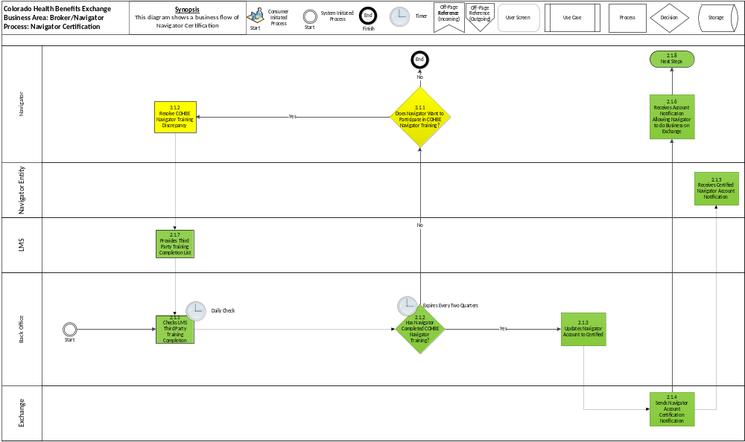

Basic (Main) Flow – Navigator Certification
The Basic Flow through this Use Case is the Back Office initiating the certification process based on the Navigator list from COHBE which will allow them to certify the Navigator to provide assistance on the Exchange. The Exchange shall provide Navigators with the ability to view and track their certification status including completion of required training courses through their online profile.

Checks LMS Third Party Training Completion
The Back Office will do a daily verification of the Navigator as having completed the COHBE specific training in order to provide assistance on the Exchange (Business Rule, Section 5.1.1).

Has Navigator Completed COHBE Navigator Training?
Based on the outcome of the Navigator check, the Back Office will progress the certification process to the next appropriate step if the training has been completed within the configurable time frame (Process Rule, Section 5.2.1).

Updates Navigator Account to Certified
After the Back Office determines the Navigator is authorized and has completed COHBE Navigator training, the Back Office will update the Navigator account to the state of being certified to provide assistance on the Exchange.

Sends Navigator Account Certification Notification
Upon account certification, the Exchange will send an email to the Navigator and Navigator Entity allowing the Navigator to provide assistance on the Exchange (Notice Requirements 5.5.3).

Receives Certified Navigator Account Notification
An email will be sent from the Exchange to notify the Navigator Entity that the Navigator is now allowed to provide assistance on the Exchange (Notices Requirements, Section 5.5.3).

Receives Account Notification Allowing Navigator to do Business on the Exchange
An email will be sent from the Exchange to notify the Navigator that they are now allowed to provide assistance on the Exchange (Notices Requirements, Section 5.5.3).

Provides Third Party Training Completion List
LMS will provide the Back Office with a list of Third Parties that have completed COHBE Navigator Training (Business Rule, Section 5.1.1).

Next Steps
The user proceeds to possible next steps, such as:
- The Navigator successfully completes certification and can log on and provide assistance on the Exchange.

Alternate Flows

COHBE Navigator Training Completion
The COHBE Navigator Training Completion Alternate Flow takes place when the Back Office determines the Navigator has not completed the COHBE specific training.

Does Navigator Want to Participate in COHBE Navigator Training?
The Navigator has the choice to complete training which will expire after 2 quarters.

Resolve COHBE Navigator Training Discrepancy
The Navigator completes COHBE Navigator training on LMS; proceed to the “Checks LMS Third Party Training Completion List” process Step, 2.1.1.

Exception Flows
There are no Exception Flows for the Navigator certification Use Case.

Specifications

Business Rules

LMS Third Party Training Verification
LMS provides a Third Party training completion list to the Back Office for Step 2.1.1. All fields must be complete using the expected data elements to check for training completion including relevant Exchanges.
- The data elements in the LMS provided list are as follows:
- Navigator Entity ID
- Navigator ID
- Name (First Name, Last Name)
- Date of Training Completion (which cannot be older than a configured amount of time)
- GAP to distinguish between SHOP and individual training

Process Rules

Has Navigator Completed COHBE Navigator Training?

If the Navigator has completed COHBE Navigator training by cross checking Navigator Entity ID, Navigator ID, Name (First Name, Last Name), and Date of Training Completion to the LMS training completion list (Yes), then proceed to the “Updates Navigator Account to Certified” process Step, 2.1.3.
- If the Navigator has not completed COHBE Navigator training by cross checking Navigator Entity ID, Navigator ID, Name (First Name, Last Name) and Date of Training Completion to the LMS training completion list (No), then proceed to the COHBE Navigator Training Completion Alternate Flow, Section 3.1.

Workflow

Worklist Definition

LMS Third Party Training Checklist

Task Name: Verify Third Party Training
- Worklist Name: Verify LMS Third Party Training
- Task Type: Back Office Staff Normal Worklist
- Sort Criteria: First In First Out (FIFO) by receipt into the Worklist
- SLA Watch: None
- SLA Warning: None
- Task Actions: Review List for Completion of Navigator Training
- Is the information complete?
- Accept? Review?
- If accepted, the Back Office will update the Navigator account and notify the Navigator and Navigator Entity of the certification to use the Exchange.
- After reviewing the documentation and it is determined to be incomplete the Navigator has the choice to complete training which will expire aftera configurable time frame.
- Comments: None

UI Screen Details
Note: There will be updates to account status displayed on Navigator account screen.

Communications

Imaging Requirements

There are no Imaging Requirements for the Navigator Certification Use Case.

Form Requirements
There are no Form Requirements for the Navigator Certification Use Case.

Notices Requirements
- BRN_002 - Navigator is Certified and can Provide Assistance - A notice to the Navigator and Navigator Entity stating the fact they are now certified with the exchange and may do tasks on the behalf of others (Basic Flow 2.1.9).

Other Communication Requirements
There are no Other Communication Requirements for the Navigator Certification Use Case.

Interfaces
There are no Interfaces requirements for the Navigator Certification Use Case.

Reporting

Navigator Training List
LMS will provide the Back Office with a Navigator training completion list, which will include:
- Navigator Entity ID
- Navigator ID
- Name (First Name, Last Name)
- Date of Training Completion (which cannot be older than a configurable amount of time).

User Experience
No user experience is used in this use case.

Business Activity
- Number of Certified Navigators
- Number of Navigators that have been nominated
- Number of Navigators in the process of LMS Training
- Number of Navigators in the process of training > than X amount of time
- Number of Navigator Denials
- Number of Navigator Appeals including Results
- Number of Navigators by Entity

Workflow
- Average queue depth
- Average time through queue
- Number of items processed through the queue

Community and Public Health
No community and public health is used in this use case.

User Security

Actor Status Changes
The Navigator will shift from a Pending Certification to a Certified status as the result of this use case.

Sensitive Data Used
No sensitive data is used in this use case.

Activity Log and Audit Trail
There are no specific Activity Log and Audit Trail requirements we should consider for the Navigator Certification Use Case.

Future Release Notes
- A future release may include the LMS Interface being real time.
- Support separate certifications for the SHOP and individual exchanges.

Appendix A - Glossary
Term | Definition
Account | An “Account” is the means by which a user can access a computer system
Authorization | “Authorization” is confirmation by a higher or secondary authority of the validity of an action taken by either a lower or primary actor of workflow on the System
COHBE | Colorado Health Benefit Exchange, “COHBE” is used interchangeably with “Exchange” throughout the documents.
DOI | The Colorado “Division of Insurance” regulates the insurance industry and assists consumers and other stakeholders with insurance issues.
DOI Authorization Standards | At this time Brokers are required to comply with the DOI Broker certification exam. Navigator’s authorization standards are TBD.
Employer | An “Employer” is a company or small business who participates in the Exchange to offer insurance and/or premium assistance to its Employee(s) or its Employee(s) and their dependents.
Exchange | During the implementation phase, the terms “Exchange” or “Exchanges” are meant to include technology, services, business processes, people, and other resources required to implement, operate and/or maintain the requirements or functions needed to support the ability for consumers to shop for and purchase health insurance. Specifically related to interpretation of a requirement, the term “Exchange” implies that the implementation of a requirement is not strictly limited to a technology solution.  - Individually, the term “Exchange” refers to each Exchange or both Exchanges as appropriate in the context.  - The Exchange is NOT a state agency but a standalone non-profit entity. It will serve as an aggregator of individual policies sold by private insurers and underwritten using the new federal and state underwriting and rating rules.  - The Small Business Health Options Program (SHOP) Exchange will support the specific needs of small employers.  - For context, the Exchanges will act much like an “Expedia or Orbitz for Health Insurance” system. They will allow individuals and small firms to obtain information, compare and purchase private health insurance plans. The Exchanges will also be the entities that will evaluate whether or not a particular insurance policy meets the criteria set out by the new federal rules for policies offered to individuals and small employers.
LMS | A learning management system (LMS) is a software application for the administration, documentation, tracking, reporting and delivery of online education courses or training programs
Navigators | “Navigators” are persons authorized to assist Customers in their activities to shop for insurance through the Exchanges.
Brokers | “Brokers” are persons certified to assist Employers and or Individuals in their activities to shop for insurance through the Exchanges.
System | The “System” means all of the software, configurations, data, processes, and equipment used to provide the Exchanges and the System is also referred to as the “solution.” During the implementation phase, “System” is taken to mean the technology component of the Exchange.
Third Party | For the purposes of the implementation phase of the project, the term “Third Party” shall mean Navigators, Brokers, Carriers, or other entities that offer products and/or services in conjunction with the Exchange or the System.
Users | “Users” are users of the Exchange authorized by COHBE and may include operators, administrators, customers, brokers, navigators, etc., who interact with the System. Users may be internal or external to COHBE.

